Asymmetric DCC correlation: EURUSD and USDCHF
Method 10 / GARCH(1,1) + Cappiello-Engle-Sheppard ADCC / Alpari D1 full available history

Study setup
Logical pair: EURUSD , USDCHF
Broker symbols: EURUSD_i , USDCHF_i
Snapshot: 2026-11-03_majors_alpari_D1
Timeframe: D1
Matched return window: 1999-01-05 to 2026-11-02 (UTC bar dates)
Matched return count n: 7186
Dropped unfinished last bar dated 2026-11-03 UTC after a tick-volume check against the prior complete day.
EURUSD GARCH(1,1): mu=0.000011, omega=0.001149, alpha=0.036723, beta=0.960004
USDCHF GARCH(1,1): mu=-0.000339, omega=0.003450, alpha=0.040980, beta=0.956768
ADCC: a=0.136115, b=0.500000, g=0.000000, a+b+g/2=0.636115
Nested DCC (g=0): a=0.136115, b=0.500000
Negative shock: n = min(z, 0) in broker quote direction (not inverted)
Burn-in ignored in path summaries and chart: first 60 updates
Complete matched rows (Excel): EURUSD-USDCHF_ADCC_D1.xlsx
Complete matched rows (HTML table): EURUSD-USDCHF_ADCC_D1_data.html

Method carried forward
Asymmetric DCC extends Engle DCC with an extra term on joint negative standardised shocks. Each matched daily log return of close, ln(close_t / close_t-1), is first filtered by a constant-mean GARCH(1,1). Then z = residual / sigma and n = min(z, 0). The Cappiello-Engle-Sheppard recursion uses A = (1-a-b) Q_bar - g N_bar with N_bar = mean(n n'). Quotes are not inverted, so a negative shock is a negative log return in the broker quote. Nested symmetric DCC (g = 0) is fit on the same z path for comparison. Constraints: a,b,g >= 0 and a + b + g/2 < 1. Path summaries ignore the first 60 updates. The headline is latest ADCC rho. Pearson r is a side check only. This is not a cause, lead, or trading signal.

Results
Latest ADCC rho: -0.752457
Latest nested DCC rho: -0.752457
Post-burn-in ADCC path (n=7126): mean=-0.760469, median=-0.767087, min=-0.945286, max=0.721349, std=0.072830
Share of post-burn-in days with |rho| >= 0.4: 99.61%; |rho| >= 0.7: 89.45%
Same-sample Pearson r: -0.749204
ADCC minus r: -0.003254
ADCC minus nested DCC: -0.000000

Conclusion
Over 7186 matched daily log-return rows for EURUSD and USDCHF (broker quote directions unchanged), latest ADCC rho is -0.7525 (negative, strong conditional linear link in this sample) with fitted a=0.1361, b=0.5000, g=0.0000. Nested symmetric DCC latest rho is -0.7525 (ADCC minus DCC = -0.0000). After a 60-day burn-in, path mean is -0.7605 and std is 0.0728. Same-sample Pearson r is -0.7492 (ADCC minus r = -0.0033). This does not establish cause, lead-lag, or a lasting trading rule.

Charts
Daily closes

Daily log returns
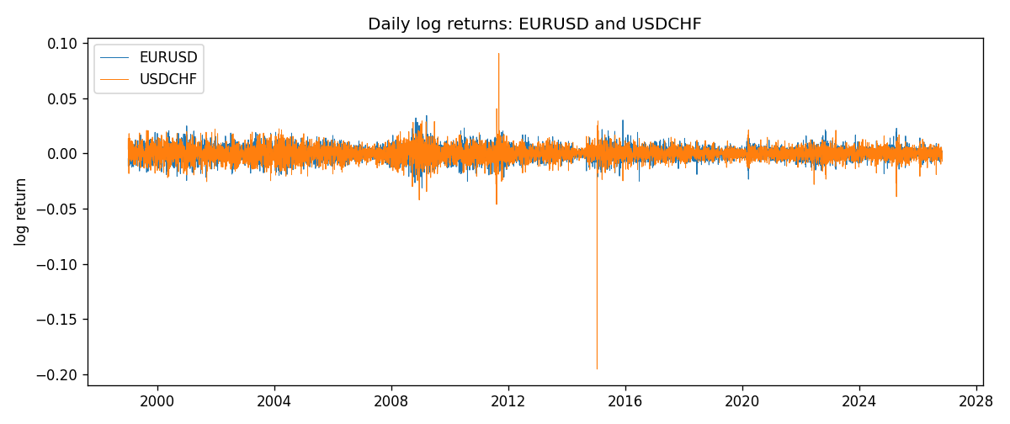
ADCC rho path with nested DCC and Pearson r
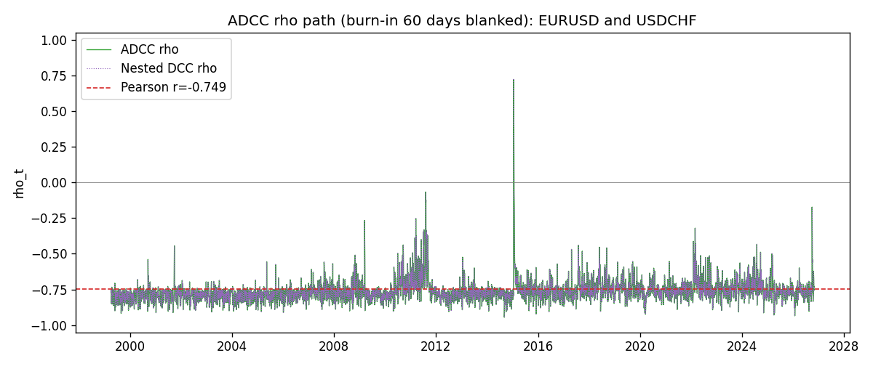

Data report
Every matched row that entered the ADCC recursion is stored in the sibling Excel workbook named EURUSD-USDCHF_ADCC_D1.xlsx. Embedding all rows as a Word table is impractical at this length; the Word file holds the column list, column summaries, and the first and last 15 matched rows.
Columns: time, EURUSD_open, USDCHF_open, EURUSD_high, USDCHF_high, EURUSD_low, USDCHF_low, EURUSD_close, USDCHF_close, EURUSD_tick_volume, USDCHF_tick_volume, EURUSD_spread, USDCHF_spread, EURUSD_real_volume, USDCHF_real_volume, EURUSD_log_return, USDCHF_log_return, EURUSD_sigma, USDCHF_sigma, EURUSD_z, USDCHF_z, EURUSD_n, USDCHF_n, q11, q22, q12, rho_adcc, rho_dcc
Column summaries (matched calculation rows)
column | count | mean | std | min | 25% | 50% | 75% | max
EURUSD_open | 7186 | 1.181536 | 0.15083018 | 0.8272 | 1.086205 | 1.16621 | 1.29401 | 1.5995
USDCHF_open | 7186 | 1.0974503 | 0.25221737 | 0.72022 | 0.9205325 | 0.9899 | 1.23765 | 1.8219
EURUSD_high | 7186 | 1.1866696 | 0.15143104 | 0.8326 | 1.090285 | 1.17131 | 1.299445 | 1.6038
USDCHF_high | 7186 | 1.102742 | 0.25396197 | 0.73305 | 0.924775 | 0.99353 | 1.2422 | 1.8313
EURUSD_low | 7186 | 1.1765242 | 0.15015364 | 0.8227 | 1.0820725 | 1.16258 | 1.2885325 | 1.5865
USDCHF_low | 7186 | 1.0923313 | 0.25063382 | 0.08565 | 0.91721 | 0.98623 | 1.2315 | 1.8121
EURUSD_close | 7186 | 1.1815785 | 0.15080545 | 0.8267 | 1.0860875 | 1.166185 | 1.2941 | 1.5997
USDCHF_close | 7186 | 1.0974447 | 0.25212504 | 0.72025 | 0.920795 | 0.98995 | 1.237525 | 1.8217
EURUSD_tick_volume | 7186 | 103207.57 | 173534.06 | 218 | 9426 | 52774.5 | 99579.75 | 1471626
USDCHF_tick_volume | 7186 | 74325.102 | 113489.5 | 18 | 12800 | 40232.5 | 70435.25 | 858589
EURUSD_spread | 7186 | 19.339549 | 16.550572 | 0 | 8 | 12 | 20 | 50
USDCHF_spread | 7186 | 26.036877 | 24.695014 | 0 | 5 | 16 | 50 | 100
EURUSD_real_volume | 7186 | 4.0330482e+10 | 1.6691688e+11 | 0 | 0 | 0 | 0 | 3.6149665e+12
USDCHF_real_volume | 7186 | 2.3290849e+10 | 8.9127816e+10 | 0 | 0 | 0 | 0 | 1.9331921e+12
EURUSD_log_return | 7186 | -3.06e-06 | 0.00580427 | -0.03123819 | -0.00324267 | 0 | 0.00325778 | 0.03433183
USDCHF_log_return | 7186 | -6.921e-05 | 0.00659379 | -0.19545699 | -0.00335085 | 8.077e-05 | 0.003323 | 0.09051364
EURUSD_sigma | 7186 | 0.0055697 | 0.00170126 | 0.0025795 | 0.00432455 | 0.00538711 | 0.0065012 | 0.01459161
USDCHF_sigma | 7186 | 0.00655102 | 0.00254802 | 0.00361664 | 0.00508343 | 0.00610332 | 0.00732583 | 0.0398893
EURUSD_z | 7186 | -0.00289811 | 1.0000319 | -5.7823167 | -0.6188072 | -0.00183838 | 0.60941324 | 5.2049235
USDCHF_z | 7186 | 0.03916316 | 0.99910676 | -34.477475 | -0.48080465 | 0.06971338 | 0.59696713 | 6.7452553
EURUSD_n | 7186 | -0.38688648 | 0.59324282 | -5.7823167 | -0.6188072 | -0.00183838 | 0 | 0
USDCHF_n | 7186 | -0.33068268 | 0.67945357 | -34.477475 | -0.48080465 | 0 | 0 | 0
q11 | 7186 | 1.0000293 | 0.2672821 | 0.73610623 | 0.83811558 | 0.92294514 | 1.069022 | 5.3140764
q22 | 7186 | 0.99987996 | 2.2144763 | 0.72883553 | 0.81468447 | 0.88630782 | 1.0119398 | 162.57845
q12 | 7186 | -0.7434098 | 0.28714148 | -3.8333069 | -0.80851047 | -0.68487851 | -0.61390491 | 12.443744
rho_adcc | 7186 | -0.76065618 | 0.07260452 | -0.94528554 | -0.7954933 | -0.76719074 | -0.74104008 | 0.72134943
rho_dcc | 7186 | -0.76065618 | 0.07260452 | -0.94528557 | -0.79549331 | -0.76719074 | -0.74104008 | 0.72134945
First 15 matched rows (selected columns)
time | EURUSD_log_return | USDCHF_log_return | EURUSD_z | USDCHF_z | EURUSD_n | USDCHF_n | q11 | q22 | q12 | rho_adcc | rho_dcc
1999-01-05 | -0.0048360507 | 0.0039424743 | -0.7356386 | 0.51050434 | -0.7356386 | 0 | 1 | 1 | -0.74356974 | -0.74356974 | -0.74356974
1999-01-06 | -0.011547966 | 0.013605652 | -1.7698016 | 1.686251 | -1.7698016 | 0 | 0.93754564 | 0.89935869 | -0.69347635 | -0.75521217 | -0.75521217
1999-01-07 | 0.0076280636 | -0.0093883841 | 1.1233689 | -1.0538511 | 0 | -1.0538511 | 1.2589966 | 1.2005992 | -1.0235237 | -0.83250454 | -0.83250455
1999-01-08 | -0.010902799 | 0.011040268 | -1.6025672 | 1.3205141 | -1.6025672 | 0 | 1.1651546 | 1.1153542 | -0.94347722 | -0.82762432 | -0.82762434
1999-01-11 | -0.007103287 | 0.0052963193 | -1.0162029 | 0.64344578 | -1.0162029 | 0 | 1.2960355 | 1.1589135 | -1.0303605 | -0.84072748 | -0.8407275
1999-01-12 | 0.0045103728 | -0.0098275602 | 0.64255862 | -1.0954905 | 0 | -1.0954905 | 1.1524644 | 0.99969651 | -0.87475586 | -0.8149651 | -0.81496511
1999-01-13 | 0.010845346 | -0.018259701 | 1.5649962 | -2.0581573 | 0 | -2.0581573 | 0.99631668 | 1.0270848 | -0.80376546 | -0.79456146 | -0.79456147
1999-01-14 | 0 | -0.0024256692 | -0.0015751677 | -0.22498328 | -0.0015751677 | -0.22498328 | 1.1954177 | 1.4540116 | -1.1108837 | -0.84260655 | -0.84260657
1999-01-15 | -0.010153245 | 0.01794228 | -1.4590522 | 2.0084223 | -1.4590522 | 0 | 0.96159436 | 1.0977807 | -0.82596763 | -0.8039134 | -0.80391341
1999-01-18 | 0.0036256946 | -0.0031856384 | 0.50863442 | -0.29472548 | 0 | -0.29472548 | 1.1344481 | 1.4618301 | -1.0824277 | -0.84053953 | -0.84053954
1999-01-19 | -0.00017235436 | -7.2518946e-05 | -0.02620021 | 0.028066087 | -0.02620021 | 0 | 0.96632337 | 1.1066236 | -0.83219251 | -0.804753 | -0.80475301
1999-01-20 | -0.0031939256 | 0.0072259871 | -0.46638464 | 0.81378164 | -0.46638464 | 0 | 0.84714029 | 0.91730418 | -0.68677035 | -0.77907126 | -0.77907126
1999-01-21 | 0.0030215416 | -0.0038232689 | 0.44466984 | -0.37714513 | 0 | -0.37714513 | 0.81706229 | 0.91267801 | -0.66561956 | -0.77079644 | -0.77079643
1999-01-22 | -0.0012075213 | -0.0001445609 | -0.18280343 | 0.021372375 | -0.18280343 | 0 | 0.79933047 | 0.83958494 | -0.62621093 | -0.76440785 | -0.76440785
1999-01-25 | -0.0030251979 | 0.0024546976 | -0.46392116 | 0.31369457 | -0.46392116 | 0 | 0.76809897 | 0.78373982 | -0.58421127 | -0.75296603 | -0.75296602
Last 15 matched rows (selected columns)
time | EURUSD_log_return | USDCHF_log_return | EURUSD_z | USDCHF_z | EURUSD_n | USDCHF_n | q11 | q22 | q12 | rho_adcc | rho_dcc
2026-10-13 | 0.0037402957 | -0.0024955621 | 1.0796665 | -0.45153811 | 0 | -0.45153811 | 1.0021257 | 0.94826547 | -0.75169553 | -0.77110923 | -0.77110923
2026-10-14 | -0.0037582255 | 0.0029388325 | -1.0846065 | 0.69303227 | -1.0846065 | 0 | 1.0236143 | 0.86576991 | -0.71277919 | -0.75715639 | -0.75715639
2026-10-15 | 0.0056053107 | -0.0097855323 | 1.5995067 | -2.0056852 | 0 | -2.0056852 | 1.0358139 | 0.86214522 | -0.72927667 | -0.77172263 | -0.77172263
2026-10-16 | 0.0017724895 | -0.0036230826 | 0.48837044 | -0.65390721 | 0 | -0.65390721 | 1.2300312 | 1.3425169 | -1.0718833 | -0.83412192 | -0.83412194
2026-10-19 | -0.0025394633 | 0.0036351779 | -0.71529557 | 0.79598849 | -0.71529557 | 0 | 1.011365 | 1.0933456 | -0.84998376 | -0.80831 | -0.80831001
2026-10-20 | 0.0023881672 | -0.0026281224 | 0.67068523 | -0.45936861 | 0 | -0.45936861 | 0.9392105 | 0.9968 | -0.77306518 | -0.79897029 | -0.7989703
2026-10-21 | -0.00032046717 | -0.00040027413 | -0.094256455 | -0.012483549 | -0.094256455 | -0.012483549 | 0.89471741 | 0.89100806 | -0.69904245 | -0.78292433 | -0.78292433
2026-10-22 | -0.0015949606 | -0.0048036381 | -0.46356678 | -0.91873778 | -0.46356678 | -0.91873778 | 0.81245316 | 0.80941041 | -0.61993507 | -0.76447388 | -0.76447387
2026-10-23 | -0.001338521 | 0.005652514 | -0.3940169 | 1.229136 | -0.3940169 | 0 | 0.79936203 | 0.88348207 | -0.52257074 | -0.62183399 | -0.62183398
2026-10-26 | -0.0022706559 | 0.0018407959 | -0.67444577 | 0.43989517 | -0.67444577 | 0 | 0.78469792 | 1.0112651 | -0.59777983 | -0.67105404 | -0.67105403
2026-10-27 | -0.004152342 | 0.0026100526 | -1.238852 | 0.60158161 | -1.238852 | 0 | 0.81814965 | 0.895857 | -0.60984721 | -0.7123367 | -0.71233669
2026-10-28 | 0.0022262927 | -0.0010142111 | 0.65052563 | -0.138789 | 0 | -0.138789 | 0.98186281 | 0.86107368 | -0.67693998 | -0.7362149 | -0.7362149
2026-10-29 | 0.0022571351 | -0.0048680164 | 0.66443221 | -0.94383839 | 0 | -0.94383839 | 0.91241814 | 0.79704391 | -0.62133324 | -0.72859554 | -0.72859553
2026-10-30 | -0.0011458446 | 0.00071594559 | -0.3446646 | 0.21887116 | -0.3446646 | 0 | 0.88018487 | 0.88366243 | -0.66660049 | -0.75584977 | -0.75584977
2026-11-02 | 0.002120569 | -0.0071459744 | 0.63650443 | -1.431741 | 0 | -1.431741 | 0.82014719 | 0.81223691 | -0.61414237 | -0.75245719 | -0.75245719

